Module A.3 - Answers

Topic 1: Network Access

1. Wi-Fi means Wireless Fidelity. It is a facility allowing computers, smartphones, or other devices to connect to the Internet or communicate with one another wirelessly within a particular area.

a. Some hardware specifications of wifi are Wifi Adapters, Wifi Routers and Modems.

b. 802.11ac wave 5 GHz

802.11n 2.4 or 5 GHz

802.11g 2.4 GHz

802.11b 2.4 GHz802.11a 5 GHz

Legacy 802.11 2.4 GHz

1. a. Bluetooth is a software used for the short-range wireless interconnection of mobile phones, computers, and other electronic devices. Bluetooth is a software which is available in most devices. It uses radio waves to send and receive signals instead of traditional wires and cables. However there are bluetooth devices that allow you to do the same. Some computers have it installed and some need additional device to perform the same function.

b. Wi-Fi provides internet connectivity to any device having the facility. Wi-Fi requires an internet service provider and a modem. Bluetooth is a wireless connecting platform which can share photos, documents and more without requiring a internet connection.

1. a. Ethernet is a system for connecting a number of computer systems to form a local area network, with protocols to control the passing of information and to avoid simultaneous transmission by two or more systems. It comes in cables of a number of styles. In the ethernet cable there is a coaxial which is the same wire you use the connect your tv to a cable box and there is also a twisted pair which is looks exactly like a telephone wire. Ethernet is also much more faster.

b. Wi-Fi and Bluetooth transmits data just like radio waves. Bluetooth is designed for short distances and small data transfers. The idea is that multiple computers have access to it and can send data at any time. Bluetooth is sharing folders, photos and more without using internet and it is commonly used in mobile and computer devices. An Ethernet cable is needed to connect the modem/router in order for devices on the network to connect to the internet. The majority of routers have multiple Ethernet ports behind them. Wi-Fi is the technology that lets PCs, laptops, mobile devices and more to connect to the internet at high speed without needing wires. Ethernet is a way of connecting computers in a local area or LAN. Ethernet is wired but faster than WiFi.

1. a. Dial-Up internet is a form of internet access that uses a special telephone network to establish a secure internet connection to a Internet Service provider. It requires a telephone, a modem and a computer to set it up. The Internet speeds are really slow because it has an outdated software. Setting up a dial-up is really inexpensive and requires putting one end of the wire into the your computer.

b. During the mid 1990s people used dial up models to connect to the Internet. They were quickly replaced when DSL was introduced in the late 90s.

1. a. Wifi hubs are the main connection point for small networks. It joins devices on the same network so they can communicate with each other. Hubs are hardware devices with many ports. Home router is also a hardware device but only has a single port.

b. Home router is a better but more complicated form of internet connection.

c. - Hubs are hardware devices with many ports.

- Home router is also a hardware device but only has a single port.

- The speed of Wifi home routers is approximately 1.3 gigabits today

1. a. Some printers use bluetooth, others have infrared, some have built in ethernet ports and some have wireless adapters. The printers could also be connected through the network. If the printer is connected through wifi then the device and printer will have the same IP address making it easy to print things. If the printer has an ethernet port then you could connect it near the wireless wifi and it will automatically connect to the network.

b. Examples of other wireless devices are garage door openers, wireless radios, wireless routers, wireless network cards, and wireless chargers.

c. Wired devices are faster and have better security, but they cost more to install and create more of a mess. Wireless devices create less clutter and you can use more devices in different places because you don’t have to set up the wires again, but things like security and signal coverage problems can be issues.

1. a.

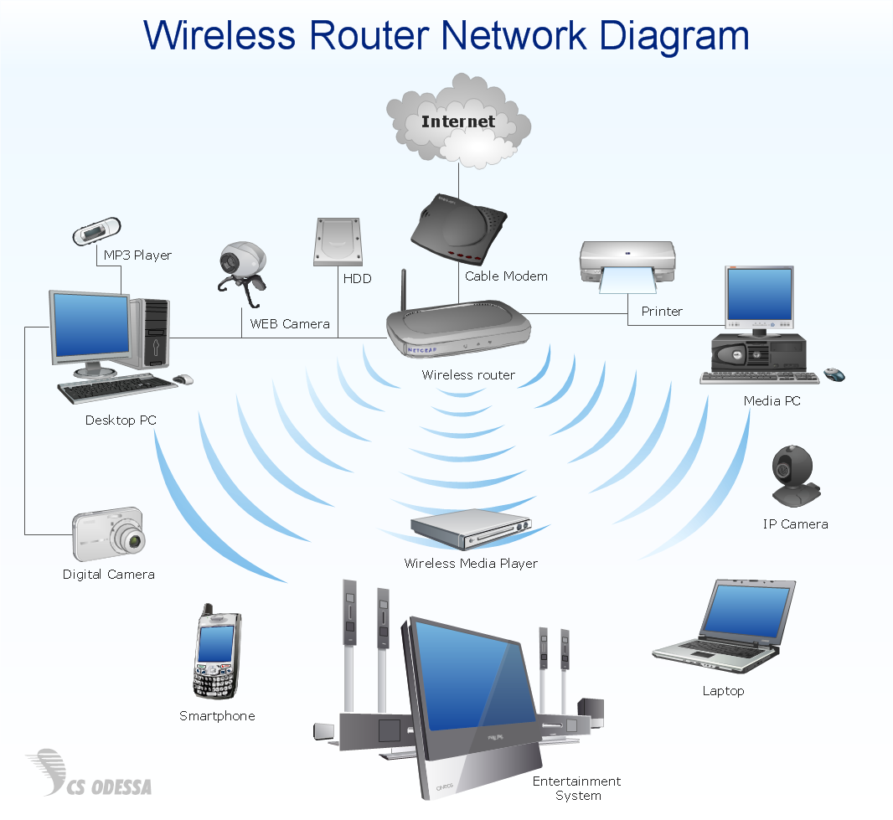

b. - Game Consoles, Laptops, Phones & Tablets are wireless connections.

Game consoles require the internet to connect to some online features to play with other people and laptops need internet for almost everything like communication to using the cloud and saving files. Cell Phones need the internet to transfer calls to other cell phone users.

- The internet, PCs, Laptops, Network Video Recorders, and IP Cameras are wired connections.

PCs have the same purpose as laptops and network video recorders need the internet to record live television networks. IP cameras need the internet to record live footage and send it to the camera companies headquarters to show live back at the surveillance system company.

Topic 2: Internet Services

1. a. An Internet Protocol address (IP address) is a numerical label assigned to each device connected to a [computer network](https://en.wikipedia.org/wiki/Computer_network) that uses the [Internet Protocol](https://en.wikipedia.org/wiki/Internet_Protocol) for communication

b. The domain name is a part of the URL, which points to the IP address.

c. The protocol allows each computer to "see" other computers on the network and share files between them.

d. Every public [Internet Protocol (IP) address](https://www.lifewire.com/what-is-a-public-ip-address-2625974) that is used on the internet is registered to an owner. The owner might be an individual or a representative of a large organization such as an [internet service provider](https://www.lifewire.com/internet-service-provider-isp-2625924). Most IP addresses do cost money.

1. a. IPv4 address are a 32-bit numeric address whereas a IPv6 address is a 128-bit numeric address. IPv4 is used to to identify devices on a network through an addressing system. The Internet Protocol is designed for use in interconnected systems of packet-switched computer communication networks. IPv6 is used to fulfill the need for more Internet addresses. It was designed as an evolutionary upgrade to the Internet Protocol and will, in fact, coexist with the older IPv4 for some time. IPv6 is designed to allow the Internet to grow steadily, both in terms of the number of hosts connected and the total amount of data traffic transmitted.

b. IPv4’s limitation is that it can only have four billion two hundred ninety-four million nine hundred sixty-seven thousand two hundred ninety-six unique address. Another limitation is that IPv4 is network address translation (NAT). Overloaded NAT and one IP with multiple private IPs behind it breaks.

c. IPv6 will be able to have more address because it has 128-bit addresses instead of 32-bit addresses. IPv6 also eliminates the need for NAT.

d. There are four steps. Step 1: IPv6 cost-benefit analysis, Step 2: Readiness assessment, Step. 3: Decide what to do with unsupported applications and infrastructure and Step 4: Plan the details of the migration.

1. a. A domain name is an identification string that defines a realm of administrative autonomy, authority or control within the Internet

b. Domain names are used to identify one or more IP addresses.

c. .com, .ca, .org and other website suffixes are known as “top-level domains” (TLDs). They all have different meanings such as:

* .com: Commercial (for-profit) websites
* .ca is the [Internet](https://en.wikipedia.org/wiki/Internet) [country code](https://en.wikipedia.org/wiki/Country_code) [top-level domain](https://en.wikipedia.org/wiki/Top-level_domain) for [Canada](https://en.wikipedia.org/wiki/Canada).
* .org: Non-profit organizations

d. Today, the Internet Corporation for Assigned Names and Numbers (ICANN) manages the top-level development and architecture of the Internet domain namespace. It authorizes domain name registrars, through which domain names may be registered and reassigned.

e. Domain names are formed by the rules and procedures of the Domain Name System (DNS). Any name registered in the DNS is a domain name.

f. To get a domain name, you have to register it in the ICANN organization and the pay the respected fee for it. No, domain names are not free (as mentioned before, you have to pay a fee).

1. a. When you enter a URL into your Web browser, your DNS server uses its resources to resolve the name into the IP address for the appropriate Web server.

b. If there is another DNS server, and the clients are configured to use it as backup, there is little affect. However, if there is no DNS server, computers on the network cannot communicate with each other, except by addressing each other by IP address.

c. They are are typically located in the internal infrastructure of Internet service providers.There are 13 DNS root servers.

d. If you changed your hosting provider or server IP, you need to update the IP address that your root domain and the other records in your DNS Settings Page. Your new hosting provider will provide the new IP address that your root domain should point it.

1. a. A DHCP Server is a network server that automatically provides and assigns IP addresses, default gateways and other network parameters to client devices.

b. Some people replace the DHCP server with routers and switches. If a DHCP server fails or goes offline, network communications can quickly break down. Without DHCP, you'd need to go to each computer and manually assign it an IP address, subnet mask, default gateway and other network settings

c. DHCP server is connected to a switch.

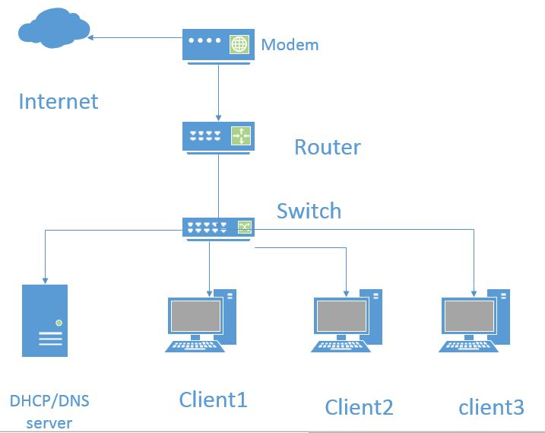

1. a. A gateway is a node (router) in a computer network, a key stopping point for data on its way to or from other networks. It is a hardware device that acts as a "gate" between two networks.

b. If there is no default gateway, the devices will have no internet. It is also possible to have an outage. It can also create an error on devices.

c. It is located in between WAN and LAN (Routers and Switches).

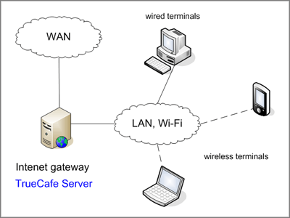

1. a. A router is a networking device that forwards data packets between computer networks. Routers perform the traffic directing functions on the Internet.

b. A network switch is a computer networking device that connects devices together on a computer network by using packet switching to receive, process, and forward data to the destination device.

c. They are located in between the devices receiving the internet (PCs, etc.) and the DSL/Cable Modem. There are typically one of each in every connection.

d.

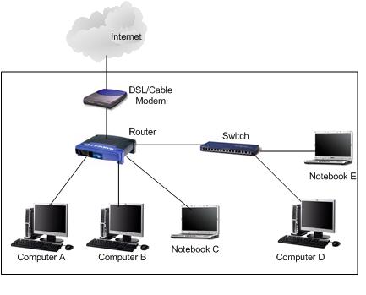

1. a. Components of a LAN are a network adapter, network medium, cable connectors, a power supply, hub/switch/router and a network software.

b. 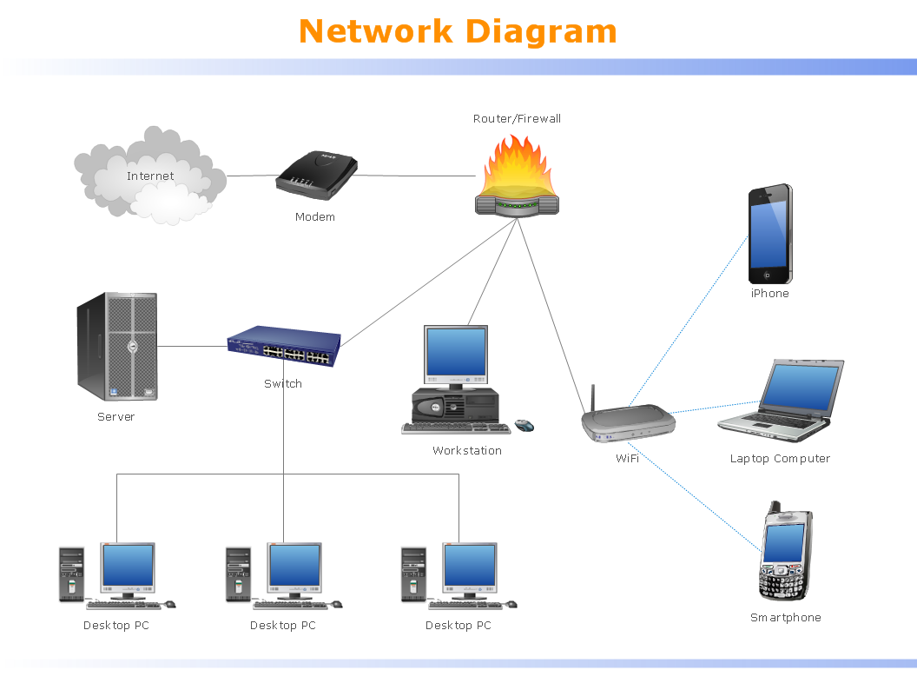

1. a. Components of WAN vary depending on the technology and configuration of the wireless WAN. For example, a satellite-based wireless WAN has different components than a cellular-based system.

b. A Local Area Network (LAN) is a private computer network that connects computers

in small physical areas whereas a Wide Area Networks (WAN) is type of computer network that connect offices which are located in different geographical locations.

Topic 3: Web Servers & Applications

Presentation done By Me!!